Prof. Dr. Xuechun Lin

Information
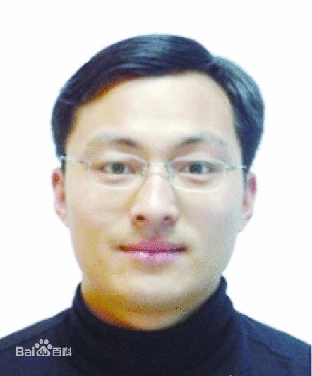
Name: Xuechun Lin Gender: Male
Date of birth: 4/1978 Mobile phone: 0086-18610566218
Email: xclin@semi.ac.cn Degree: Doctor
Reach field: all-solid-state laser technology Position: Laboratory director
Contact address: Institute of Semiconductors, Chinese Academy of Sciences
No. A 35, Qinghua East Road, Haidian District, Beijing P. R. China; Post code: 100083
Education and work experiences
10/2007~Now, Professor, Laboratory director, Institute of Semiconductors, Chinese Academy of Sciences
8/2005~9/2007, Associate professor, Institute of Semiconductors, Chinese Academy of Sciences
5/2004~7/2005, Research assistant, Institute of Semiconductors, Chinese Academy of Sciences
9/1999~5/2004, Doctor Degree, Key Laboratory of Optical Physics, Institute of Physics, Chinese Academy of Sciences
9/1995~7/1999, Bachelor Degree, Department of Applied Physics, Yunnan University
Personal summary
Prof. Xuechun Lin is the laboratory director of all-solid-state light source, institute of Semiconductors, Chinese academy of sciences. He is also the director of all-solid-state laser advanced manufacturing engineering technology research center. He achieved 3 kilo-watt, 4 kilo-watt, 6 kilo-watt and 8 kilo-watt laser output for the first time in China. He broke a series of key technologies of industrial high-power solid-state lasers and developed a variety of high power all-solid-state laser products and realized its industrial applications, which promoted the high-power all-solid-state lasers applied in industry. His research achievements have been awarded major innovations of Chinese Academy of Sciences and Ministry of Science and Technology of the People’s Republic of China. He has undertaken many 863 key projects, 973 projects, and instrument developing projects of the Chinese Academy of Sciences. He has been invited as special speaker at the international laser and laser processing conferences for many times. Now he is the executive director of the optical society of Beijing, a member of Chinese materials research center and the optical society of America. Besides, he is the evaluation expert of 863 key project and NSFC projects. He is the reviewer for several magazines, such as “Optics Express”, “Chinese Physics Letters”, “Chinese Optics Letters”. He has published more than 60 research papers and applied 70 patents.
Work achievements
- Optimized high-power all-solid-state laser welding equipments. The performances of the equipments are reliable and stable, with the same effect of the similar foreign products.(2010)
- Developed high-power solid-state laser welding equipments, the performance of the equipments are reliable and shows long-term stability in the engineering environment.(2009)
- For the first time developed five-kilowatt solid-state lasers, owns independent intellectual property rights.(2008)
- Developed eight-kilowatt solid-state lasers, which was at the leading domestic level and laid the foundation for the applications of lasers in China’s industrial promotion.(2006~2008)
- For the first time applied disc crystal on lasers and obtained blue laser output. (2004)
- For the first time applied new nonlinear crystal BiBO to compensate walk-off angle and obtained watt-level blue laser full-wave band tunable output.(2003)
- For the first time achieved all-solid high power mid-infrared laser output.(2002)
- Obtained the highest output power of all-solid CW blue laser. (2001~2004)
- For the first time mixed red, green and blue lasers and obtained white laser, which laid the foundation for laser full color display.(October, 2002)
Major published papers
 | Authors | Title | Journal
1 | Ling Zhang, Kai Li, Xuechun Lin*, et al. | A 7.81 W 355 nm ultraviolet picosecond laser using La2CaB10O19 as a nonlinear optical crystal | Opt. Express 22: 17187~17192 (2014)
2 | Y.B. Wang, S.S. Zhao, X.C. Lin* | Microstructure and properties of laser cladding FeCrBSi composite powder coatings with higher Cr content | Journal of Materials Processing Technology 214:899~905 (2014)
3 | Kai Li, Ling Zhang, Xuechun Lin, et al. | High-power picosecond 355 nm laser based on La2CaB10O19 crystal | Opt. Lett. 39: 3305~3307 (2014)
4 | Ying-Ying Yang, Armin Scrinzi, Xue-Chun Lin, et al. | High-harmonic and single attosecond pulse generation using plasmonic field enhancement in ordered arrays of gold nanoparticles with chirped laser pulses | Opt. Express 21: 2195~2205 (2013)
5 | H. J. Yu, L. Zhang, X. C. Lin* | Sub-100 ns solid-state laser Q-switched with double wall carbon nanotubes | Opt. Commun. 306: 128~130 (2013)
6 | Shilian Yan, Ling Zhang, Xuechun Lin*, et al. | Passive Q-switching in a diode-sidepumped  Nd:YAG laser at 1.319 μm | Optical Engineering 52(10):  106107(10/2013)
7 | L. Zhang, H.J. Yu, X.C. Lin*, et al. | A 1319nm diode-side-pumped Nd:YAG laser Q-switched with graphene oxide | Journal of Modern Optics 60:1287~1289 (2013)
8 | M. Li, W. Zhao, X. Lin, et al. | High efficiency continuous-wave single-frequency Nd:YVO4 ring laser under diode pumping at 880 nm | Appl. Phys. B 106: 593~597 (2012)
9 | M. L. Li, W. F. Zhao, X. C. Lin* | 1.86 W cw single-frequency 1319 nm ring laser pumped at 885 nm | Appl. Opt. 51: 1241~1244 (2012)
10 | L. Zhang, Y. G. Wang, X. C. Lin*, et al. | 20 W High-Power Picosecond Single-Walled Carbon Nanotube Based MOPA Laser System | Journal of Lightwave Technology 30: 2713~2717 (2012)
11 | S. B. Zhang, L. Guo, X. C. Lin, et al. | High Electro-to-Optical Efficiency 180 W Q-Switched 532 nm Laser with a Pulse width of 70 ns | Applied Physics B 104: 861~866 (2011)
12 | B. Xiong, J. L. Ma, X. C. Lin, et al. | High-power, high-repetition-rate mid-infrared generation with PE-SRO based on a fan-out periodically poled MgO-doped lithium niobate | Opt. Commun. 284: 1391~1394 (2011)
13 | L. Zhang, Y. G. Wang, X. C. Lin, et al. | Passively Mode-Locked Nd:YVO4 Laser Using a Single-Walled Carbon Nanotube Saturable Absorber Pumped by 880nm Laser Diode | Japanese Journal of Appl. Phys. 50: 122703 (2011)

