Chinese Internet Neologisms From a Sociolinguistic Perspective: The Case of “City Bu City”

DAVID PUBLISHING

D

LI Yan

Donghua University, Shanghai, China

The wide spread of online communication has fueled the emergence of Internet neologisms, offering valuable insights into the sociolinguistic impact on language innovation. This study investigates the sociolinguistic dimensions of Chinese Internet neologisms, taking “city bu city” as a representative case. Through a mixed-methods approach, including quantitative and qualitative analyses, this study tries to explore its lexical, semantic, and morphological features, as well as the socio-cultural factors underlying its widespread usage. Using tools like Web Corp Live and Baidu Index, this research will trace the diachronic spread of “city bu city” and provide insights into the mechanisms of its popularity. The findings contribute to enhance the comprehension of language dynamics in the digital era, as well as the interplay among language, society, and technology.

*Keywords:* neologism, Chinese Internet neologisms, sociolinguistics

Introduction[1]

With the rapid development of social media and online communication platforms, new words—termed “Internet neologisms”—have emerged, reflecting cultural and linguistic creativity. These neologisms, often created and popularized by netizens, not only reflect the dynamic nature of language, but also serve as a mirror of societal trends, cultural identity, and technological influence. Among these, the Chinese Internet neologism “city bu city” has gained significant traction, capturing the attention of both linguists and the general public. By examining “city bu city”, this study aims to shed light on how digital communication shapes language innovation and how such innovations, in turn, reflect broader social and cultural dynamics.

Neologisms somewhat reflect the social progression and netizens’ attitudes. With a dramatic upsurge in the number of netizens, Chinese Internet neologisms are mushrooming. According to CNNIC, Internet users in China have surged in recent years. By January 2025, the number of netizens in China had swelled to nearly 1.11 billion, with an Internet penetration rate of 78.6%. This widespread usage has garnered significant attention from the Chinese government, linguists, and lexicographers (Zhuo & Shu, 2018). *Yaowen-Jiaozi*, a language and literature journal established in 1995, has maintained a tradition of annually releasing the “Top 10 Internet Words” of the Chinese Internet based on the sociological value and linguistic value of language. It is said that the “Top 10 Internet Words” list is determined by linguistic experts and highlights the words that embody the innovative spirit of the Chinese language and the distinctive hallmarks of the times. The latest list, released in December 2024 includes: “digital intelligence”, “AI-for-Good”, “future-oriented industries”, “city bu city” (city or not city), “ying kong” (hard control), “shui ling ling de” (freshly and lively), “ban wei” (working daed), “song chi gan” (chill mood), “silver-haired power”, and “kid bro/kid sis”.

This study builds on the existing body of work on Internet neologisms, such as Song (2019) and Tao (2017), which analyze the socio-linguistic and cultural implications of Internet neologisms. By focusing on “city bu city”, this research will uncover the mechanisms behind its creation, usage, and spreading, contributing to a broader understanding of contemporary Chinese sociolinguistics, specifically Internet neologisms. The significance of studying Internet neologisms lies in their ability to capture the zeitgeist of a particular era. These new terms often as hybrid linguistic forms, resonating with a globalized, bilingual audience. Social media platforms, with their pervasive influence, serve as catalysts for the rapid creation and dissemination of such neologisms, enabling them to gain traction almost overnight. Their viral nature is further amplified by their ability to evoke emotional resonance among netizens.

The study of Internet neologisms also offers valuable insights into the dynamic nature of language. Unlike traditional vocabulary, which evolves gradually over time, Internet neologisms exhibit a rapid lifecycle, reflecting the fast-paced nature of online culture. This unique characteristic makes them a unique window for examining contemporary societal trends and the adaptive nature of language in modern contexts.

In short, by examining the creation and dissemination behind “city bu city”, this research aims to deepen our understanding of the interplay between language and society in the digital age. As Internet neologisms continue to proliferate, they will undoubtedly remain a rich area of study for sociolinguists and other scholars interested in the evolving nature of communication.

Literature Review

To begin with, the emergence and prevalence of social media platforms, such as Weibo, WeChat, the Red, and TikTok have deconstructed the traditional process of information production (e.g., newspaper and broadcast). Liu, Yao, and Han (2019) proposed the convergence trend of online social media, noting that groups that were difficult to gather in the real world can now converge in various online forums, group chats, and communities. The dissemination of Internet neologism is inextricably linked to the channel advantages of the Internet, with social media playing a pivotal role in the spread of emerging culture.

The term neologism originates from the French word “néologisme”, combining the prefix “néo”, meaning “new”, with the root “logos”, meaning “words” to refer to newly coined words. *Cambridge Dictionary* defines neologism as “a new word or expression, or a new meaning for an existing word”. Peterson and Ray (2013) described neologism as a newly coined word or phrase that is just emerging into mainstream use. Neologisms may be attributed to a specific individual, or they may be the outcome of a publication, period, or event.

The emergence of Internet neologisms has been extensively studied within sociolinguistics, highlighting the dynamic interplay among language, society, and technology. The theory of covariance, proposed by Bright (1985), suggests that language development is inextricably linked to the gradual or abrupt transformations of social life. That is to say, the evolution of vocabulary is a mirror of societal progress, with neologisms emerging as a result of the interactions between language and society. Neologisms, as Krishnamurthy (2010) emphasized, emerge from processes like word formation, borrowing, and lexical deviation, which highlight their adaptive and innovative characteristics. These processes are deeply embedded in the dynamic nature of language, wherein elements are shaped by cultural and social forces.

The unique socio-cultural and technological landscape of China provides fertile ground for the emergence of Internet neologisms. Tao (2017) defined Internet neologisms as words or expressions that develop in online spaces but have yet to become part of the mainstream language. These expressions serve as a linguistic outlet for netizens, offering brevity, humor, and cultural specificity. Zhuo and Shu (2018) argued that Chinese Internet neologisms provide insight into China’s evolving lexicon and social identity. Platforms like Weibo, WeChat, and TikTok have become instrumental in shaping and disseminating such expressions, allowing neologisms like “city bu city” to gain virality and cultural resonance.

While Internet neologisms enrich language, their transient nature poses challenges for linguistic research. Liu and Lin (2018) argued that the rapid evolution of digital communication creates a constantly shifting linguistic landscape, making it difficult to capture and analyze neologisms comprehensively. The Internet has enabled netizens from different backgrounds to engage in cultural “collisions”, reconstructing people’s language system at an extremely fast pace, and reorganizing the old language expression patterns into forms that are more in line with contemporary lifestyles. The language of a human being is dynamic, so new words of a language are not only changes of language symbols, but also reflection of the times.

However, the widespread use of Internet neologism may contribute to the erosion of formal language structures (Gao & Cui, 2022). This tension between linguistic innovation and preservation underscores the need for balanced approaches to studying and integrating Internet neologisms into mainstream language.

Theoretical Framework and Research Methodology

## Sociolinguistics

Sociolinguistics, a discipline that emerged in the 1960s, is a branch of language science and an integral part of linguistics. It employs linguistic and sociological frameworks to examine how social factors influence a language, the complex interplay between language and society. By analyzing linguistic data, sociolinguistics seeks to interpret social events and uncover the ways in which language both reflects and constructs social realities.

In the context of this study, sociolinguistics is used to examine the emergence and dissemination of Internet neologisms like “city bu city”. These neologisms are not merely linguistic innovations but also social artifacts that encapsulate contemporary experiences, and the influence of digital communication. This research explores how “city bu city” shapes the way in which netizens express and negotiate their emotions in online spaces, and highlights the integral role of sociolinguistics in understanding the evolving relationship between language, society, and technology in the digital era.

## Neologism Model

According to Krishnamurthy (2010), a neologism is resulted from word formation, borrowing, and lexical deviation. Firstly, word formation is based on compounding, blending, affixation, coinage, and acronym. Morphemes are defined as minimal units of words carrying complete meaning. The second component is borrowing. The speakers integrate elements from other languages to facilitate communication. Depending on the context and circumstances, speakers may appropriate entire phrases or individual words to enhance the effectiveness of their communication, thereby enriching the language’s vocabulary. The third component is lexical deviation. It occurs when a word is made up, a completely new word that has not existed before. This is called neologism, or the invention of new words.

This framework will be complemented by quantitative linguistics to analyze big data trends and patterns (see Figure 1).

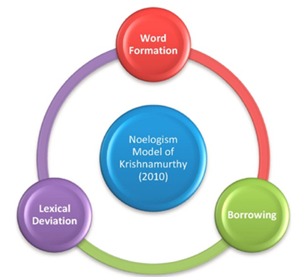

*Figure 1.* Neologism model (Krishnamurthy, 2010).

## Research Methodology

The quantitative approach is selected to ensure systematic data collection and statistical analysis, providing objective insights into the patterns of neologism. The present study takes Web Corp Live and Baidu Index as research tools. Web Corp Live is a large-scale search engine capable of analyzing vast corpora of authentic texts (collected from the web) to discern both typical and rare or unusual usages in language, as well as to delineate the grammatical and semantic features of words or phrases. Hence, Web Corp Live is employed in this study to explore the semantic and grammatical features of the neologism “city bu city”.

Baidu Index was developed by Baidu, Inc., which is one of the largest Internet search engine companies globally. Baidu search engine manages trillions of data generated daily by netizens, which in fact is truly big data. Baidu Index allows users to track the search frequency and trend for certain hot words and phrases. As the data within Baidu Index are refreshed daily, it is properly suitable for investigating the diachronic spreading features of the Chinese Internet neologism “city bu city”.

## Research Process

Step 1: Compile authentic instances of “city bu city” from Web Corp Live to analyze its lexical and morphological properties.

Step 2: Obtain search data from Baidu Index to measure the term’s popularity and spread over time.

Step 3: Perform a comparative analysis of linguistic findings with the statistical trends to establish a link between the term’s linguistic creativity and its social reception.

Results and Discussion

## Morphological Process

Based on the neologism model proposed by Krishnamurthy (2010), “city bu city” can be regarded as a neologism derived from the Chinese digital sphere. It can be regarded as a product of coinage, where “city” is borrowed from English, and “bu”, a Chinese character, translates to “not” or “no” in English. The concatenation of these elements exemplifies linguistic economy, rendering the phrase not only concise but also a flowing sense. Secondly, the word “city” within this neologism bears a new meaning. While maintaining its original orthographic form, the word “city” has been extended and metaphorized. In the context of “city bu city”, it now transcends its denotative reference to metropolitan areas, such as Shanghai or Beijing, implying a broader and more abstract concept that encapsulates the essence of urbanity and modernity. This semantic shift underscores the dynamic nature of language and its capacity to adapt to the evolving cultural and social backgrounds.

## Linguistic Features

In June 2024, US vlogger Bao Bao Xiong uploaded his travel video “city bu city”, meaning “city or not city”. It soon went viral across various social media platforms. “City bu city” asks whether a place is fashionable and has a metropolis-like ambiance. Beyond its literal connotation of an urban area, the word “city” now also implies a sense of urbanization. According to Bao Bao Xiong, the “city” in his video refers to fashion and modernity, as well as sensations of excitement and joy. And the following parts deal with the grammatical and semantic features of “city bu city”.

A total of 191 concordance instances were retrieved based on Web Corp Live (see Table 1).

Table 1

*Partial Concordances of “City Bu City”*

|  |  |  |
| --- | --- | --- |
| City是城市的意思，但  今年入选的是唯一的字母词汇  2024年7月，外交部发言人毛宁回应  多家公司申请注册商标，申请人包括 | “city不city”  “city不city”  “city不city”  “city不city” | 显然不是“城市不城市”的意思。  是唯一的字母词汇  走红：中国就在这里，欢迎大家来。 |
| 大自然那就是“不 | city” |  |
| 非常狼狈的赶时间感叹“我不  一方面，  啥是  环球时报社评：  我觉得，  长城美不美啊？长城 | city  “city不city”  “city不city”  “city不city”  “city不city”  city不city | 了”意思就是说自己一点也不松弛  踩中了当代人对个性化、娱乐  ？新的打卡潮流出现了  的走红并非偶然  可以延展到很多事情上，比如和  啊? |
| 喝奶茶city不city | city不city | 啊 |

After carefully reading the concordance data, it is observed that “city bu city” functions both as a noun and as an adjective. For instance:

(1) noun: 啥是“city不city”？新的打卡潮流出现了。 (What does “city or not city” mean? A new trend has emerged.)

(2) adjective: 我不city了。 (I’m not in a chill mood.)

Upon analyzing the concordances, it is found that the semantic meaning of “city” from “city bu city” carries connotations of stylish, trendy, modern, and chill. This expression is used to express a sense of wonder upon arriving in a new city, or to convey a state of leisurely comfort. In doing so, it operates within an atypical context, fulfilling an adjectival role to characterize the qualities of a given situation. Although this usage deviates from the conventional application of “city”, it remains comprehensible within this specific contextual framework, demonstrating the flexible and adaptive nature of language in response to the evolving needs of expression.

In terms of the semantic meaning of “city bu city”, this neologism constructs and conveys a kind of positive semantic prosody and also expresses somewhat an element of humor or entertainment within the cyber communications among Chinese netizens. Its popularity is attributed not solely to its linguistic hybridity of foreign and Chinese elements, but more fundamentally, it highlights the embrace of modern and international Chinese culture since it was coined after Bao Bao Xiong toured around many modern Chinese cities.

## The Diachronic Spreading State of “City Bu City”

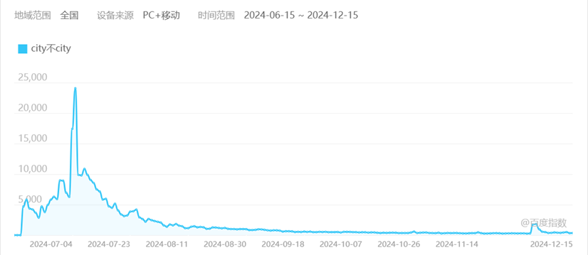

*Figure 2.* The diachronic spreading state of “city bu city” within the past six months (Retrieved from https://index.baidu.com/baidu-index-mobile/index.html#/).

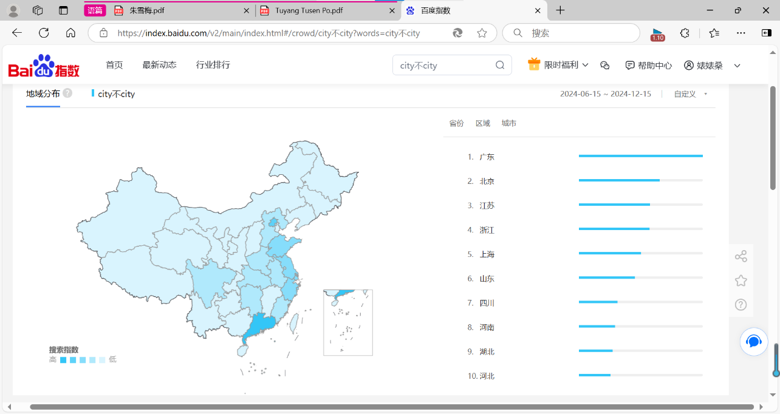

*Figure 3.* The macro spreading state of “city bu city” in different provinces of China (Retrieved from <https://index.baidu.com/baidu-index-mobile/index.html#/>).

The current research collected data within the period from June 15, 2024 to December 15, 2024 (see Figure 2). As time went by, the frequency of “city bu city” exhibited an upward trend, indicative of its rising popularity among the general populace. The fluctuation range reached its zenith in July, coinciding with a notable event related to this neologism when the Ministry of Foreign Affairs spokesperson mentioned “city bu city” and called for tourists to visit China. Despite the subsequent decline in frequency within the same month, which indicates the short-live feature of Internet neologisms, a relatively stable contingent of netizens in China continues to use this neologism to express their ideas and attitudes in China Internet. On the other hand, netizens in some provinces, such as Tibet, Sinkiang, hardly use this neologism. More details of macro-scope spreading centre of “city bu city” can be seen from Figure 3.

## Reasons

This section tries to answer the question: “Why ‘city bu city’ went viral on the Internet?” This thesis thinks of three main reasons: the convenient accessibility to various media channels, the inherent requirement for linguistic evolution, and netizens’ need for individuality and entertainment.

To begin with, the emergence and prevalence of social media platforms, such as Weibo, WeChat, the Red, and Tiktok have deconstructed the traditional process of information production. Liu et al. (2019) proposed the convergence trend of social media in the Internet, noting that groups which were difficult to gather in real world can now converge in various online forums, group chats, and communities. The dissemination of contemporary slang is inextricably linked to the channel advantages and traffic mechanisms of the Internet, with social media playing a pivotal role in the spread of emerging culture. Behind the buzzword “city or not city” are China’s efforts such as its visa-free policy that brings in more foreigners to experience Chinese culture. Since the implementation of the 144-hour transit visa exemption policy in China, an increasing number of foreign visitors have come to China for sightseeing and tourism. Chinese travel videos have become hit for many overseas influencers, with beautiful scenery, delicious food, high-speed rail travel, and the warm hospitality of the Chinese people earning praise as “好city啊！” (very chill or fashionable) from foreign tourists. This demonstrates that the neologism “city bu city” resonates with both Chinese and international netizens. Additionally, due to the support of such policies, this term has been able to rapidly spread across social media platforms.

Secondly, language is a dynamic system. It is revealed by quantitative linguistics and corpus linguistics that language is a complex-dynamic adoptive system and human-driven system (Liu & Lin, 2018). The change and development of language are caused by language users. The Internet has enabled netizens from different backgrounds to engage in cultural “collisions”, reconstructing people’s language system at an extremely fast pace, and reorganizing the old language expression patterns into forms that are more in line with contemporary lifestyles. The language of a human being is dynamic, so new words of a language are not only changes of language symbols, but also reflection of the development of the times.

“City bu city” is a representative of Chinese Internet neologisms, for it combines Chinese and English to form a new expression. This neologism exhibits replicability, meaning that it is readily reproducible by individuals across various contexts. The mutual imitation and replication of ideas within the cultural domain among people are a direct consequence of the replicability inherent in language. Moreover, the word “city” bears new meaning. It is now understood to transcend its literal reference to urban areas, such as Shanghai or Beijing, and can also be employed to convey a sense of humor, exclamation, and a relaxed ambiance. From the perspective of linguistic economy, this attribute is one of the strengths of Internet language. It demonstrates a time-saving characteristic in the spreading of Internet neologisms and facilitates netizens’ ability to achieve desired communicative effects through the most concise means.

Thirdly, Internet neologisms are netizen-driven. Social media constitute a vast media conglomerate. Emotional recognition can significantly affect the virality of news, implying that the mental process of speakers is reflected in the ever changing vocabulary. The netizens prefer to create a more relaxed communication atmosphere online. Modern youth exhibit a propensity for novelty and a disdain for the old, which manifests in their speech as a preference for using individualized neologisms. High percentage of netizens are teenagers and young adult; youth comprise a significant and highly active segment of the online population, thus facilitating the “breakout” of a newly coined term into the mainstream. These neologisms originate from online discourse, and the normalization of online life leads to the widespread adoption of these terms, eventually transitioning them into everyday language use. The language is human-driven, and words consist of the language. Hence, the Chinese Internet neologisms are also netizen-driven.

Conclusion

In summary, this study has systematically examined the linguistic features of “city bu city” as a representative case of Chinese Internet neologisms. The findings reveal that its widespread popularity is driven by both internal linguistic mechanisms and external socio-cultural factors. It contributes to the connotation and form of language. The active role of netizens shapes language evolution through their participation in the creation, interpretation, and dissemination of new lexical forms. Nonetheless, in the complex online environment where new terms constantly emerge, one must be vigilant against the complete displacement of formal language by Internet slang.

The underlying linguistic value and spreading mechanism it embodies call for further observation and research regarding their impact on contemporary Chinese mainstream culture. As this study solely selects “city bu city”, it has certain limitations and future research could explore the cross-linguistic influence of Chinese Internet neologisms, particularly how they are perceived, adapted, and integrated into other languages. Subsequent studies can build on the reciprocal exchange of linguistic elements in the field of digital sociolinguistics.

References

Bright, W. (1985). *Introduction: The dimensions of sociolinguistics*. Retrieved from https://www.degruyterbrill.com/document/doi/  
10.1515/9783110856507-003/html

Gao, F., & Cui, M. Y. (2022). Revelations from a decade of changes in Chinese internet catchphrases. *Journalism Lover, 37*(4), 60-64.

Huang, R. C., Schmidt, J. Z., & Meisterernst, B. (2019-03-11). *The Routledge handbook of Chinese applied linguistics*. London and New York: Taylor and Francis.

Krishnamurthy, S. (2010). The chutnification of English: An examination of the lexis of Salman Rushie’s *Midnight’s children*. *Journal of Social and Cultural Studies, 13*(1), 11-28.

Liu, H. T., & Lin, Y. N. (2018). Methodology and trends of linguistic research in the era of big data. *Journal of Xinjiang Normal University (Philosophy and Social Sciences), 39*(1), 72-83.

Liu, J., Yao, H. T., & Han, L. F. (2019). Research on user profile depiction and public opinion guidance strategy construction for college students: A case study of China University of Petroleum. *Journalism Communication, 35*(24), 106-107.

Peterson, C. M., & Ray, C. M. (2013). Andragogy and metagogy: The evolution of neologisms.*Journal of Adult Education, 42*(2), 80-85.

Song, Z. (2019). Is the spreading of Internet neologisms netizen-driven or meme-driven? Diachronic and synchronic study of Chinese Internet neologism Tuyang Tusen Po. *Theory and Practice in Language Studies, 9*(11), 1424-1432.

Tao, Y. (2017). An investigation into Chinese Internet neologisms. *Canadian Social Science, 13*(12), 65-70.

Zhuo, J. S., & Shu, K. (2018). Chinese neologism. In C. R. Huang, Z. Jing-Schmidt, and B. Meisterernst (Eds.), *The Routledge handbook of Chinese applied linguistics* *(to appear)*. London/New York: Routledge.

1. LI Yan, postgraduate student, College of Foreign Languages, Donghua University, Shanghai, China.